Sessions will be every Tuesday from 12-1pm EST
March 12, 2024 | Prevention and Early Intervention: Building Resilience and Connection
March 19, 2024 | What Might We Be Seeing- The Underlying Cause
March 26, 2024 | Getting Help When We Need It- Resources and Working With Families
April 2, 2024 | What Can We Do As Individuals
April 9, 2024 | Practical Strategies For This Moment In Time
April 16, 2024 | Learn About youth Mental Health First AId
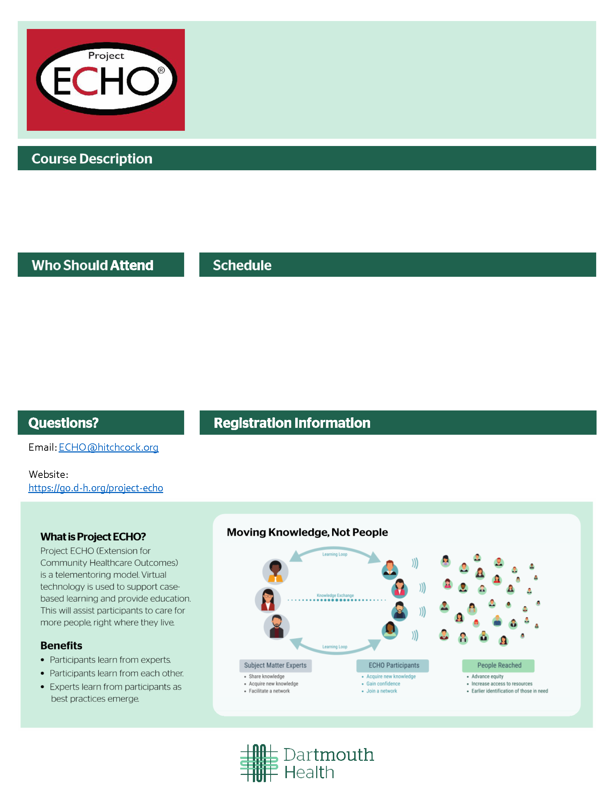
*REGISTRATION IS FREE
To register, visit:
This training is supported by the Health Resources and Services Administration (HRSA) of the U.S. Department of Health and Human Services (HHS) as part of an award totaling $1.8 million with 0% financed with non-governmental sources. The contents are those of the author(s) and do not necessarily represent the official views of, nor an endorsement, by HRSA, HHS, or the U.S. Government.

See
- Coaches
- Scout leaders
- Faith leaders
- Music/drama/art teachers
- Rec center leaders, i.e. YMCA - summer camps/programs
- Librarians
- Anyone in position to mentor youth

This interactive, web-based learning series will provide tools for school staff, coaches, and community youth leaders to better support the increased number of youth under stress and in distress. Nationally and in our communities, youth are experiencing continuing increases in anxiety, depression, trauma, and suicidal ideation, to where we are now in a widely recognized youth mental health crisis. Our goal is to provide information and resources to help those in the community address this crisis that is affecting schools, camps, faith communities, and teams today, along with an opportunity for discussing de-identified situations and receiving peer support

Recognizing and Responding to Youth in Distress ECHO

A Dartmouth Health program to help support
communities in New Hampshire

